My Portal Page Site Plan / Design Document

Logo: 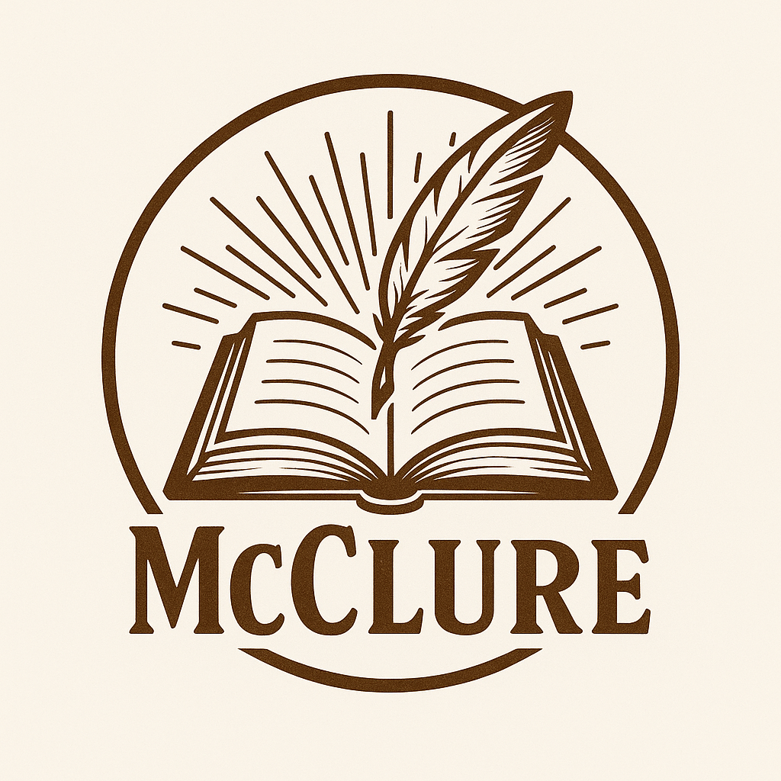

Color Scheme:
Primary Color - #faebd7 Antique white
Secondary Color: #6C4621 Kobicha
Tertiary Color: #562E0C Seal brown
Accent Color 1: #1F3C54 Prussian blue
Accent Color 2: #602020 Caput mortuum

Fonts:
Header: Verdana, Arial, Sans-serif
Paragraph: Arial, Sans-serif

